API SPECIFICATION DOCUMENT
Project Name: DevExplorer
Implementation: HybridADT Interface
Author: Asad Ullah (3482-2024)
Version: 2.0
1. Executive Summary
This document specifies the Abstract Data Type (ADT) interface for the DevExplorer backend. The API follows a "Hybrid" design, combining multiple classical data structures (Trees, Tries, and Inverted Indices) to provide high-performance file operations. The API is designed to be platform-independent and UI-agnostic.
2. Global Exception & Error Handling
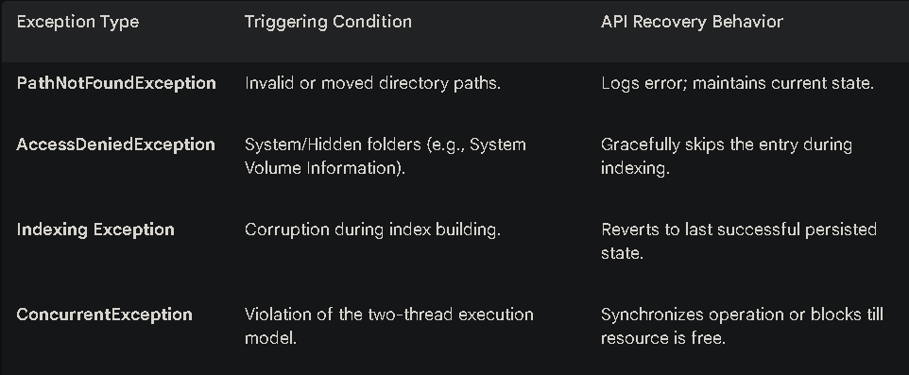
To ensure the "Fail-Safe Behavior" mentioned in the project report, all methods implement the following error handling strategy:

3. Data Model Definitions
These models are used as return types for the API methods.
3.1 FileMetadata (Record)
- String path: Absolute system path.
- boolean isDirectory: True if the object is a folder.
- long size: File size in bytes.
- String extension: File type (e.g., ".java").

3.2 FileEvent (Record)
- EventType type: CREATE | MODIFY | DELETE.
- Path path: The affected filesystem resource.
4. Method Specifications
4.1 Navigation API
Defines how the ADT models and navigates the filesystem hierarchy.
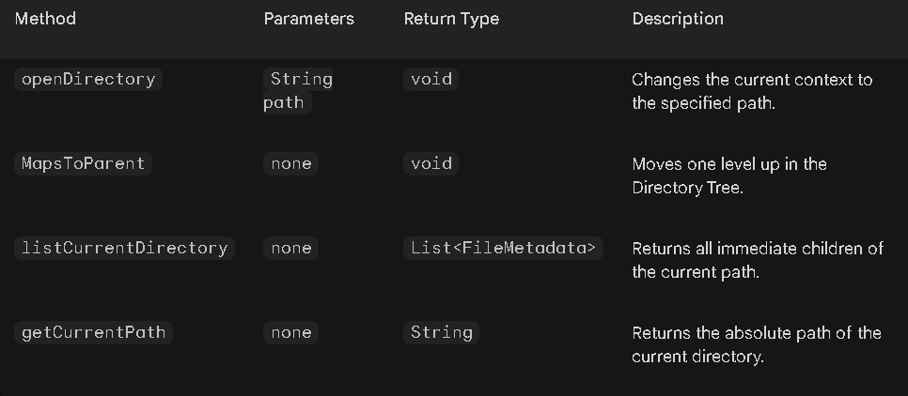

4.2 Search API
Treats search as a navigation primitive using high-efficiency data structures.
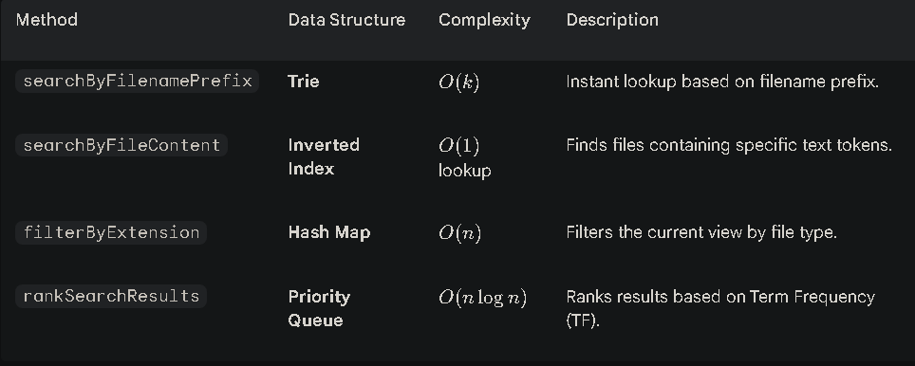

4.3 Indexing & Persistence API
Manages the lifecycle of the hybrid index and disk serialization.
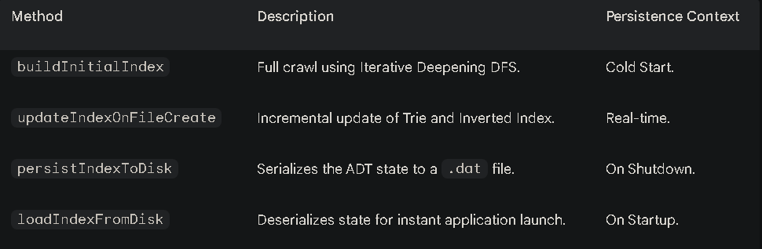
4.4 Developer Utility API
Convenience methods for developer-centric workflows.
- openTerminalHere(): Invokes cmd.exe or powershell.exe at the current path.
- toggleCodeMode(boolean): When enabled, the API automatically applies .ignore rules.
- applyIgnoreRules(List<String> patterns): Filters out node_modules, .git, and build artifacts from indices.
5. System Concurrency Contract
The DevExplorer API strictly enforces a Two-Thread Limit:
- Main/UI Thread: Responsible for Navigation and Search query execution.
- Background Indexer Thread: Responsible for building and updating indices.
Note: Any method modifying the Index (e.g., updateIndexOnFileModify) is internally synchronized to prevent race conditions during search operations.

